[](https://ok.ru/dk?cmd=PopLayerPhoto&st.layer.cmd=PopLayerPhotoOuter&st.layer.type=FRIEND&st.layer.revNav=off&st.layer.limitedUi=false&st.layer.sphotoIds=834027858226;834027857970;834027857714;834027857458;834027857202;834027856946&st.layer.showNav=on&st.layer.photoAlbumId=666792729394&st.layer.epm=off&st.layer.photoId=834027858226&st.layer.opl=off&st.layer.navStartPhotoId=834027858226&st.layer.sbd=off&st.cmd=userMain&st._aid=StatusLayer_openPhotoLayer)

[](https://ok.ru/dk?cmd=PopLayerPhoto&st.layer.cmd=PopLayerPhotoOuter&st.layer.type=FRIEND&st.layer.revNav=off&st.layer.limitedUi=false&st.layer.sphotoIds=834027858226;834027857970;834027857714;834027857458;834027857202;834027856946&st.layer.showNav=on&st.layer.photoAlbumId=666792729394&st.layer.epm=off&st.layer.photoId=834027857970&st.layer.opl=off&st.layer.navStartPhotoId=834027857970&st.layer.sbd=off&st.cmd=userMain&st._aid=StatusLayer_openPhotoLayer)

[](https://ok.ru/dk?cmd=PopLayerPhoto&st.layer.cmd=PopLayerPhotoOuter&st.layer.type=FRIEND&st.layer.revNav=off&st.layer.limitedUi=false&st.layer.sphotoIds=834027858226;834027857970;834027857714;834027857458;834027857202;834027856946&st.layer.showNav=on&st.layer.photoAlbumId=666792729394&st.layer.epm=off&st.layer.photoId=834027857714&st.layer.opl=off&st.layer.navStartPhotoId=834027857714&st.layer.sbd=off&st.cmd=userMain&st._aid=StatusLayer_openPhotoLayer)

[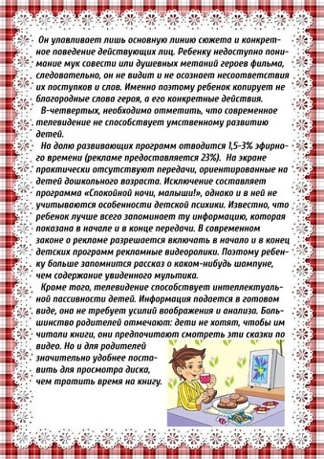](https://ok.ru/dk?cmd=PopLayerPhoto&st.layer.cmd=PopLayerPhotoOuter&st.layer.type=FRIEND&st.layer.revNav=off&st.layer.limitedUi=false&st.layer.sphotoIds=834027858226;834027857970;834027857714;834027857458;834027857202;834027856946&st.layer.showNav=on&st.layer.photoAlbumId=666792729394&st.layer.epm=off&st.layer.photoId=834027857458&st.layer.opl=off&st.layer.navStartPhotoId=834027857458&st.layer.sbd=off&st.cmd=userMain&st._aid=StatusLayer_openPhotoLayer)

[](https://ok.ru/dk?cmd=PopLayerPhoto&st.layer.cmd=PopLayerPhotoOuter&st.layer.type=FRIEND&st.layer.revNav=off&st.layer.limitedUi=false&st.layer.sphotoIds=834027858226;834027857970;834027857714;834027857458;834027857202;834027856946&st.layer.showNav=on&st.layer.photoAlbumId=666792729394&st.layer.epm=off&st.layer.photoId=834027857202&st.layer.opl=off&st.layer.navStartPhotoId=834027857202&st.layer.sbd=off&st.cmd=userMain&st._aid=StatusLayer_openPhotoLayer)

[](https://ok.ru/dk?cmd=PopLayerPhoto&st.layer.cmd=PopLayerPhotoOuter&st.layer.type=FRIEND&st.layer.revNav=off&st.layer.limitedUi=false&st.layer.sphotoIds=834027858226;834027857970;834027857714;834027857458;834027857202;834027856946&st.layer.showNav=on&st.layer.photoAlbumId=666792729394&st.layer.epm=off&st.layer.photoId=834027856946&st.layer.opl=off&st.layer.navStartPhotoId=834027856946&st.layer.sbd=off&st.cmd=userMain&st._aid=StatusLayer_openPhotoLayer)Начало формыКонец формы